

**Private and Confidential**

This document contains information which is confidential and proprietary to the Federal Tax Authority. Any dissemination, distribution, copying, use of or reliance upon the confidential and proprietary information contained herein is unauthorized and strictly prohibited.

Excise 311 for Non-Registered Business Refund

User Manual

Date: May 2024

Version 1.0.0.0

Document Control Information

Document Version Control

|  |  |  |  |
| --- | --- | --- | --- |
| **Version No.** | **Date** | **Prepared/Reviewed by** | **Comments** |
| 1.0 | 28-May-24 | Federal Tax Authority | User Manual for EmaraTax Portal |

Annexure

The below are the list of User manuals that you can refer to

|  |  |  |
| --- | --- | --- |
| **S. No** | **User Manual Name** | **Description** |
| 1 | Register as Online User | This manual is prepared to help you navigate through the Federal Tax Authority (FTA) website and create an EmaraTax account with the FTA. |
| 2 | Manage online user profile | This manual is prepared to provide you an understanding on Login process, user types, forgot password and modify online user profile functionalities. |
| 3 | User Authorisation | This manual is prepared to provide you an understanding on Account Admin, Online User, and Taxable Person account definitions and functionalities. |
| 4 | Taxable person dashboard | This manual is prepared to help the following ‘Taxable person’ users to navigate through their dashboard in the Federal Tax Authority (FTA) EmaraTax Portal: •    Registered for VAT •    Registered for Excise •    Non-registered Taxpayer •    Tax Group •    Warehouse Keeper •    Freight Forwarder/VAT Clearing Company (TINCO) •    Excise Tax Clearing Company (TINCE) |
| 5 | Link TRN to email address | This manual is prepared to help you navigate through the Federal Tax Authority (FTA) website to Link TRN to New Email Address. |

Navigating through EmaraTax

The Following Tabs and Buttons are available to help you navigate through this process

| **Button** | **Description** |
| --- | --- |
| **In the Portal** | |
|  | This is used to toggle between various personas within the user profile such as Taxable Person, Tax Agent, Tax Agency, Legal Representative etc |
|  | This is used to enable the Text to Speech feature of the portal |
|  | This is used to toggle between the English and Arabic versions of the portal |
|  | This is used to decrease, reset, and increase the screen resolution of the user interface of the portal |
|  | This is used to manage the user profile details such as the Name, Registered Email address, Registered Mobile number, and password |
|  | This is used to log off from the portal |
| **In the Business Process application** | |
|  | This is used to go the Previous section of the Input Form |
|  | This is used to go the Next section of the Input Form |
|  | This is used to save the application as draft, so that it can be completed later |
|  | This menu on the top gives an overview of the various sections within the. All the sections need to be completed in order to submit the application for review. The Current section is highlighted in Blue and the completed sections are highlighted in green with a check |

The Federal Tax Authority offers a range of comprehensive and distinguished electronic services in order to provide the opportunity for taxpayers to benefit from these services in the best and simplest ways. To get more information on these services Click [Here](https://www.tax.gov.ae/en/services/)

Non-Registered Business Excise Tax Refund

Document Control Information 2

Annexure 2

Navigating through EmaraTax 3

Non-Registered Business Excise Tax Refund 4

Refund Details 16

Review and Declaration 32

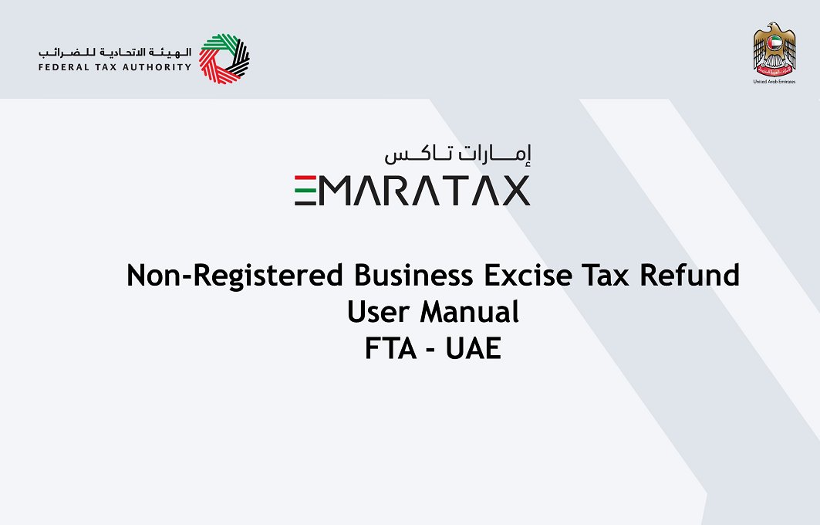

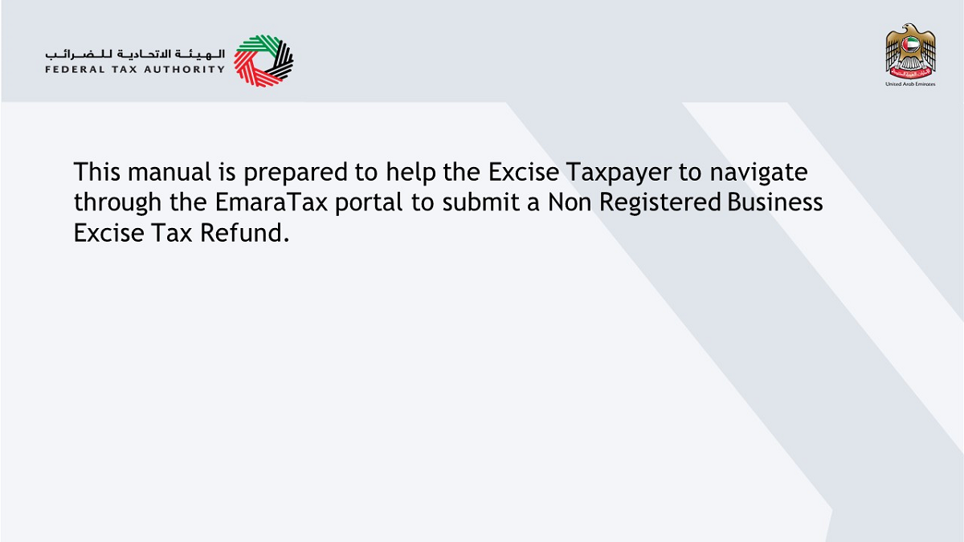

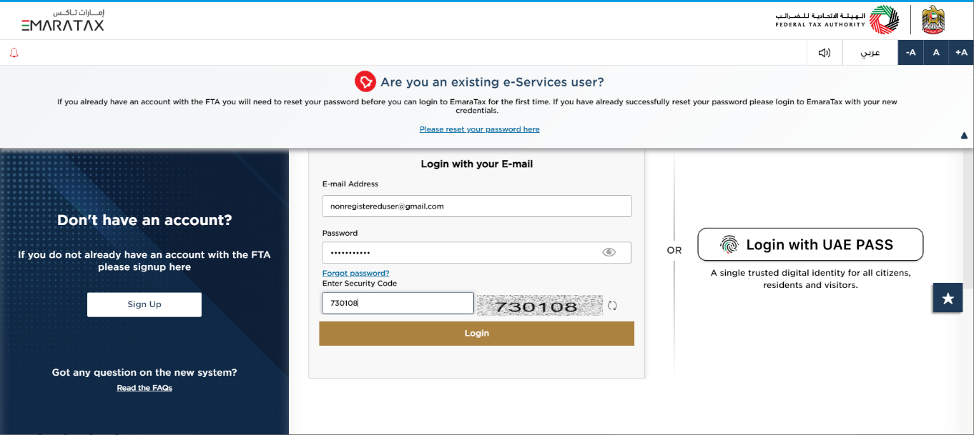

| Information | • You can login into the EmaraTax account using your login credentials or using UAE Pass. If you do not have an EmaraTax account, you can sign-up for an account by clicking the ‘sign up’ button. If you have forgotten your password, you can use the “forgot password” feature to reset your password.  • If you login via your registered email and password, on successful login, the EmaraTax online user dashboard will be displayed. If you had opted for 2 factor authentication, you will be required to enter the OTP received in your registered email and mobile number to successfully login.    • If you wish to login via UAE Pass, you will be redirected to UAE Pass. On successful UAE Pass login, you will be redirected back to the EmaraTax online user dashboard. |
| --- | --- |

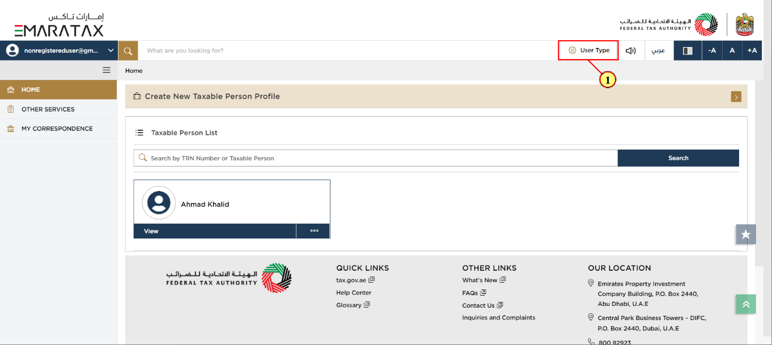

| Step | Action |
| --- | --- |
| (1) | Click here to select the user type |

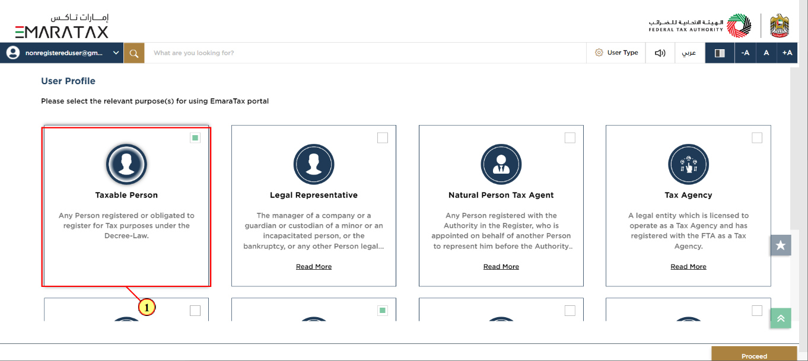

| Step | Action |
| --- | --- |
| (1) | Select the Taxable Person tile |

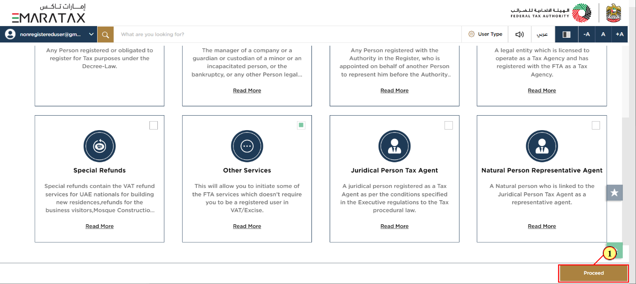

| Step | Action |
| --- | --- |
| (1) | Click on 'Proceed' to proceed to the Taxable Person |

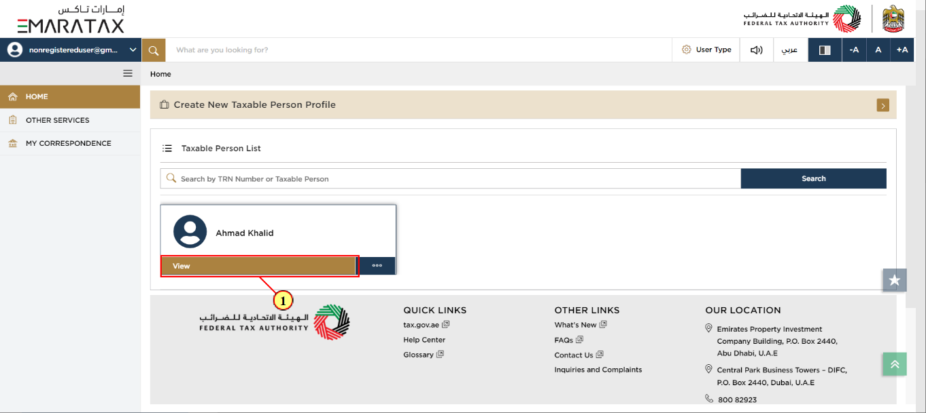

| Step | Action |
| --- | --- |
| (1) | Click here to view the Taxable Person dashboard |

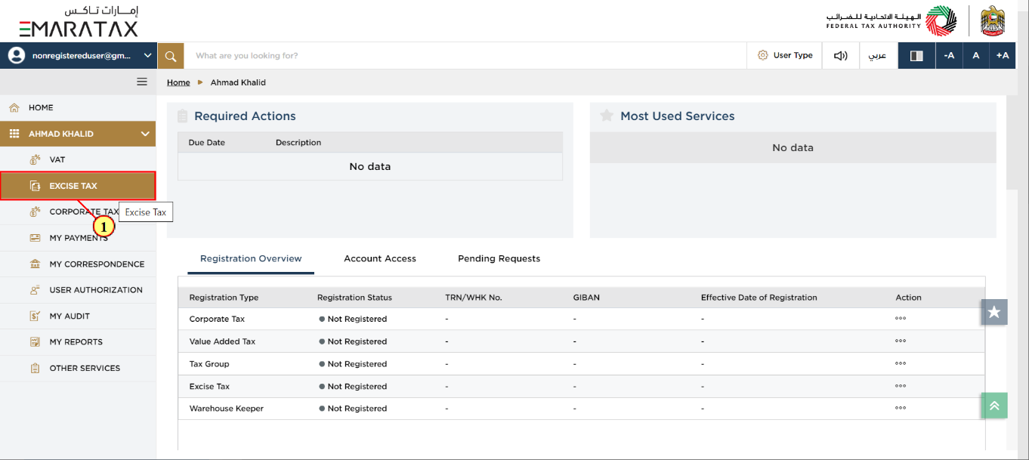

| Step | Action |
| --- | --- |
| (1) | Click here to access Excise Tax module |

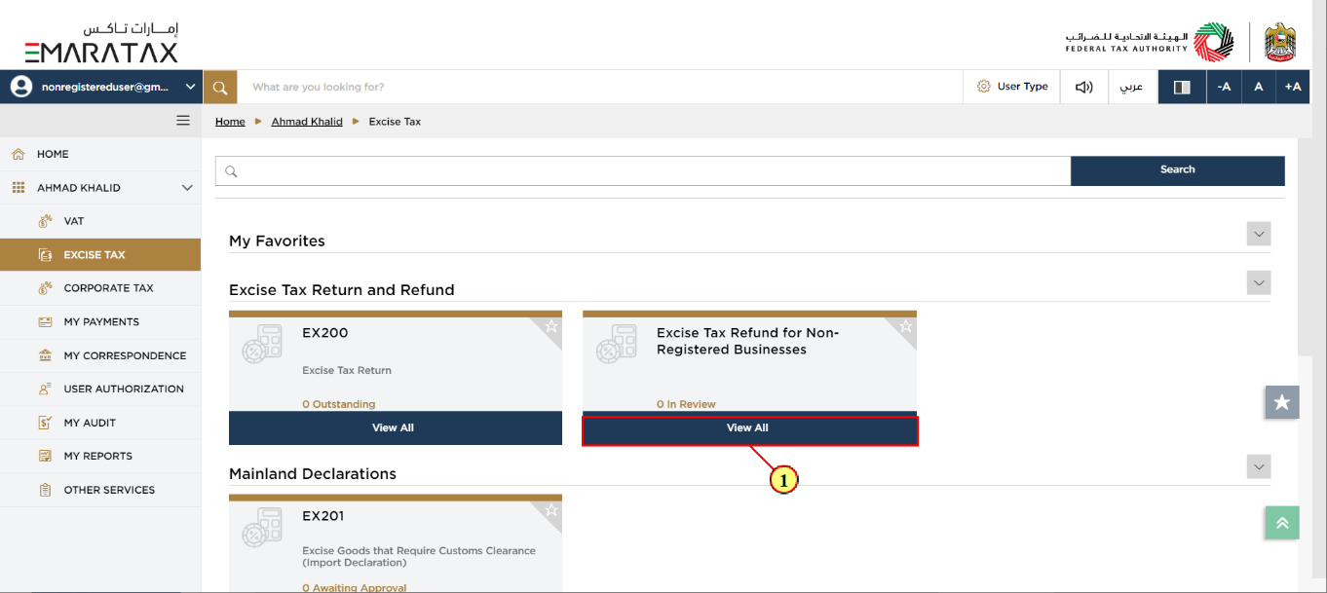

| Step | Action |
| --- | --- |
| (1) | Click here to view the dashboard of Non Registered businesses |

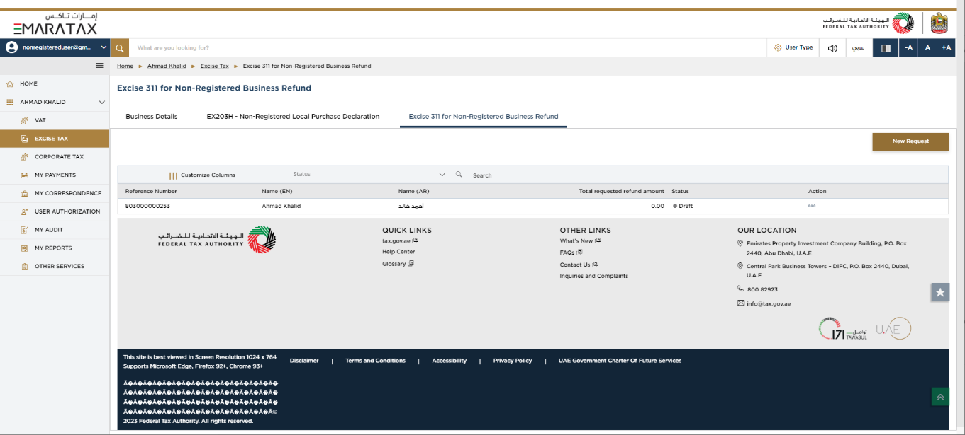

| Information | This dashboard displays information related to your previous EX 311 non registered Business refund requests. |
| --- | --- |

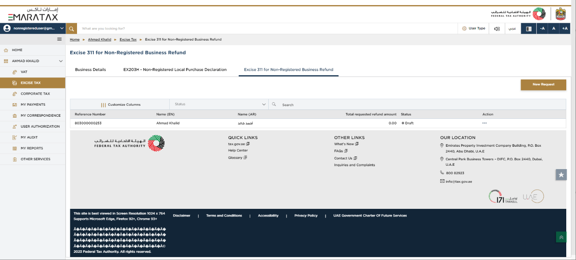

| Information | You can add a new column to the table or filter the refund applications by its status. You can also search for an application by the refund application number |
| --- | --- |

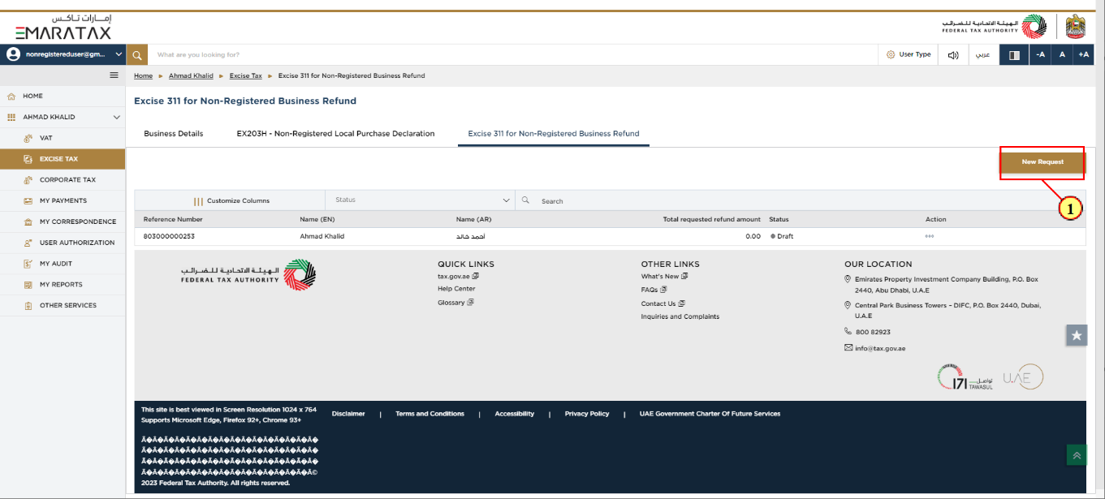

| Step | Action |
| --- | --- |
| (1) | Click on 'New Refund Request' to initiate a new refund request. |

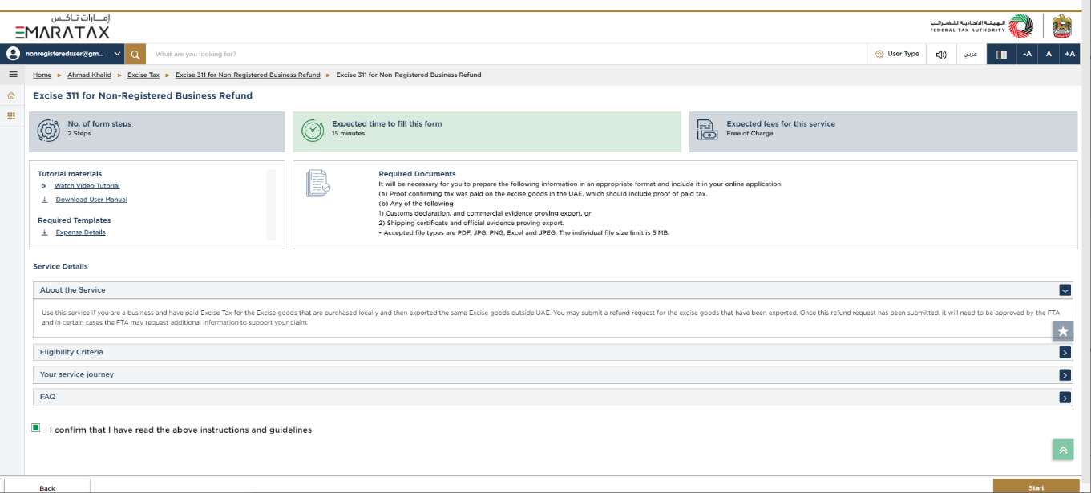

| Information | These are the instructions and guidelines which detail key information such as required templates, supporting documentation, eligibility criteria and the expected time to complete this refund request. |
| --- | --- |

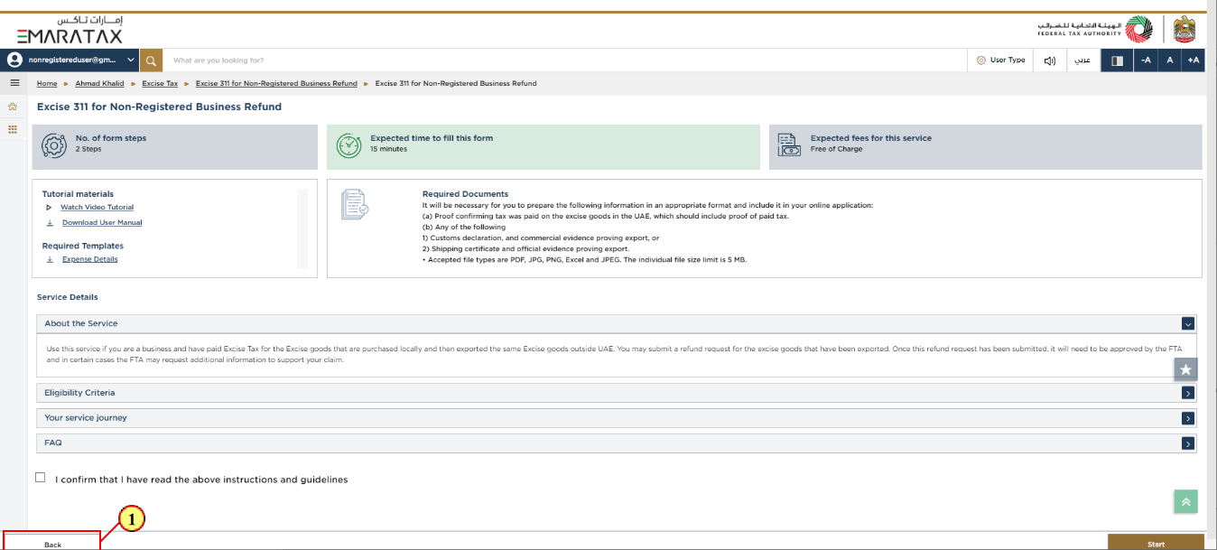

| Step | Action |
| --- | --- |
| (1) | Click on 'Back' to go back to the previous page |

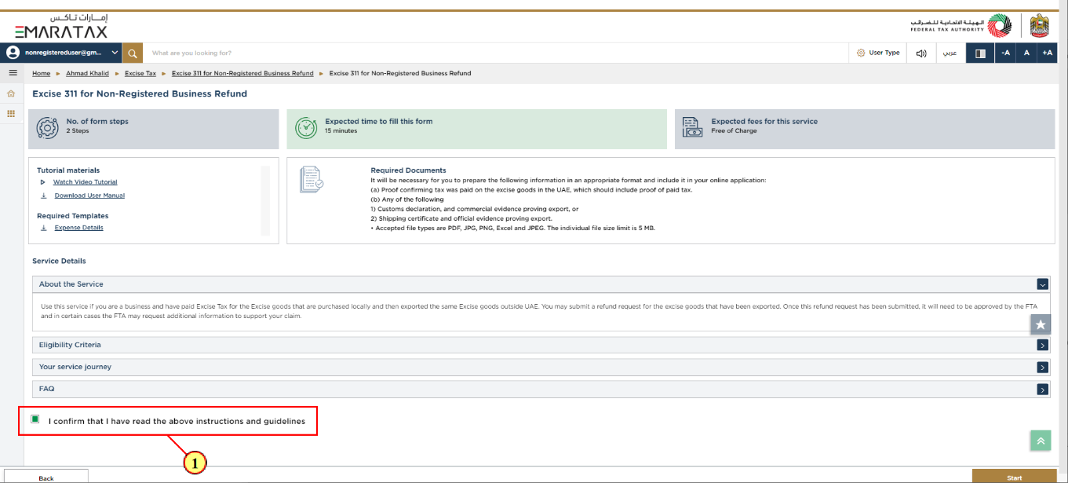

| Step | Action |
| --- | --- |
| (1) | Mark the checkbox to confirm that you have read and understood the instructions and guidelines. |

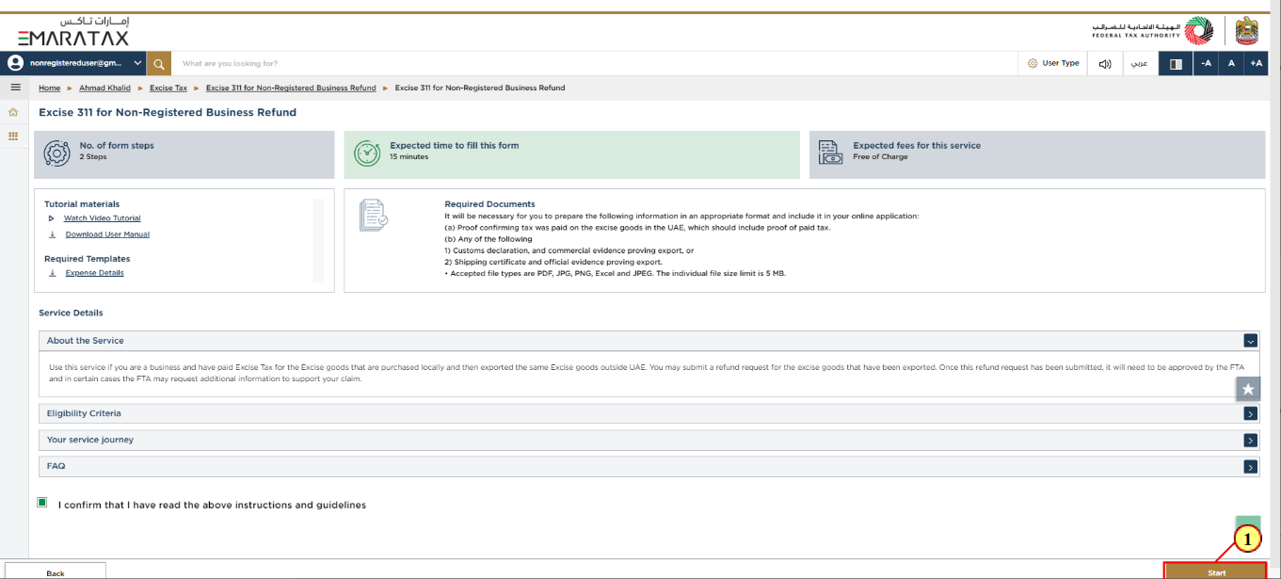

| Step | Action |
| --- | --- |
| (1) | Click on 'Start' to proceed to the refund request. |

Refund Details

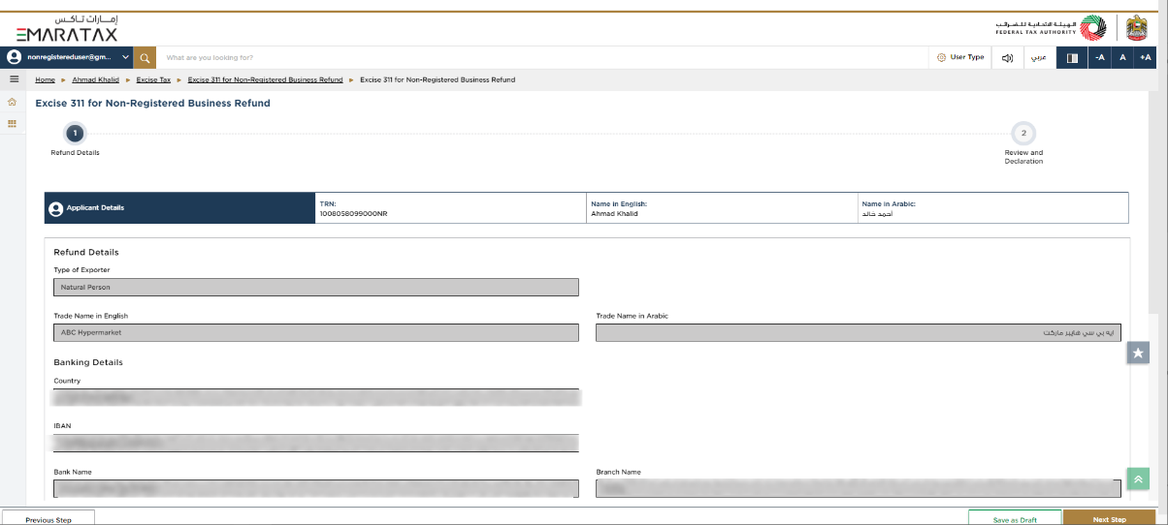

| Information | The progress bar displays the number of steps required to complete the declaration. The step you are currently in is highlighted in blue. Once you progress to the next section successfully, the previous step will be highlighted in green |
| --- | --- |

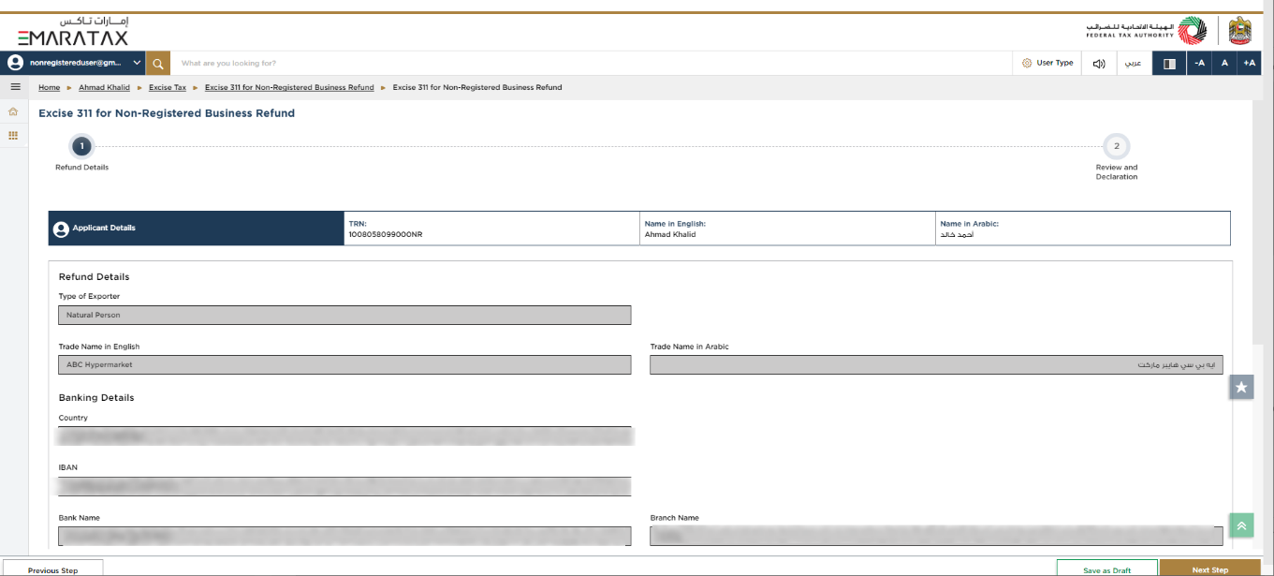

| Information | This section displays the basic details of the Non-Registered Business based on the data in Business details. |
| --- | --- |



| Information | Bank details are pre-populated from registration data. Please ensure that the bank details are correct prior to the submission of the refund request as incorrect bank details may lead to payment failure |
| --- | --- |

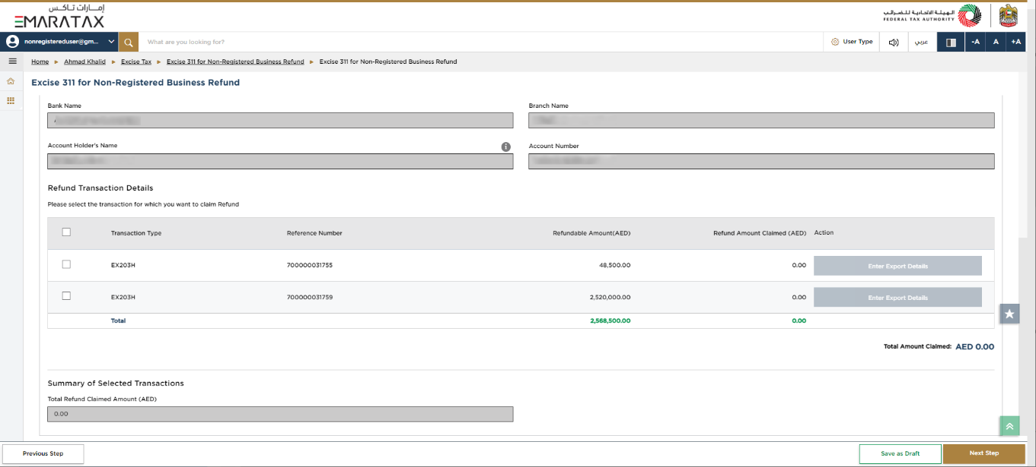

| Information | This section displays the relevant transaction types and the excess refundable amount |
| --- | --- |

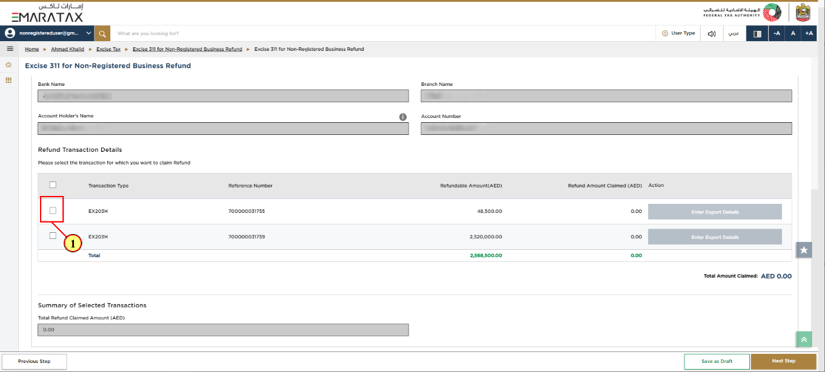

| Step | Action |
| --- | --- |
| (1) | Click here to select the declaration for which you want to claim Refund |

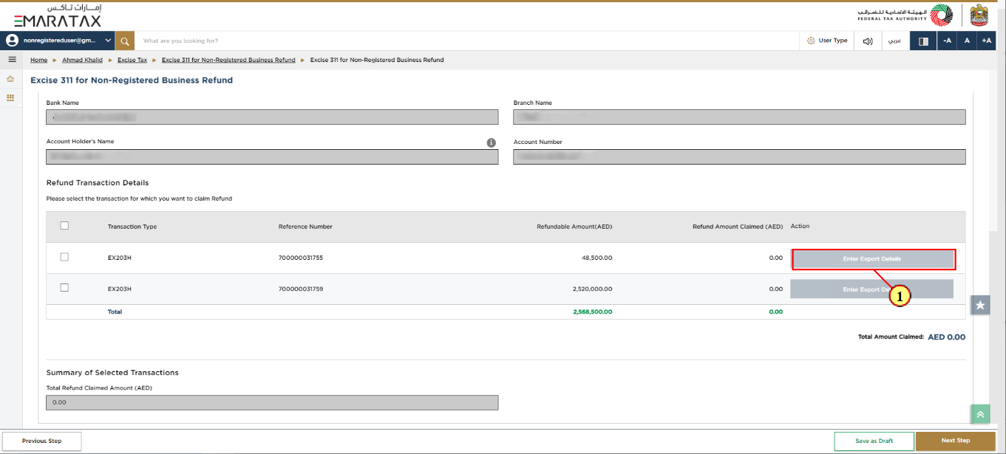

| Step | Action |
| --- | --- |
| (1) | Click here to enter the export details. |

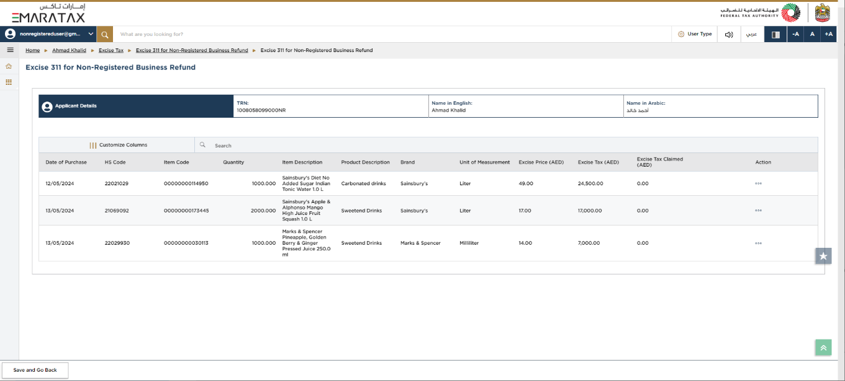

| Information | You can add a new column to the table or filter the Excise Goods by its status. You can also search for Excise Goods by item or HS code. |
| --- | --- |

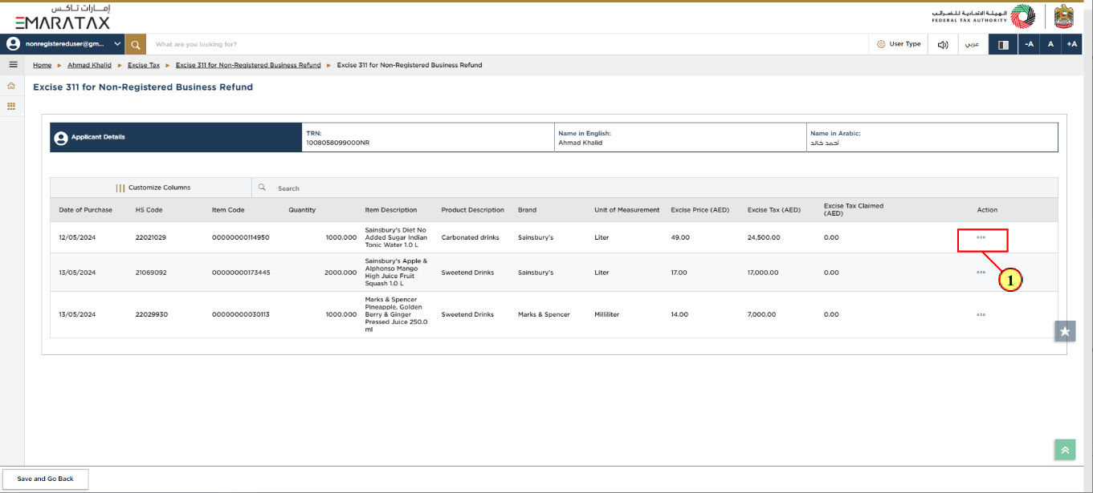

| Step | Action |
| --- | --- |
| (1) | Click on the ellipsis to edit the item details. |

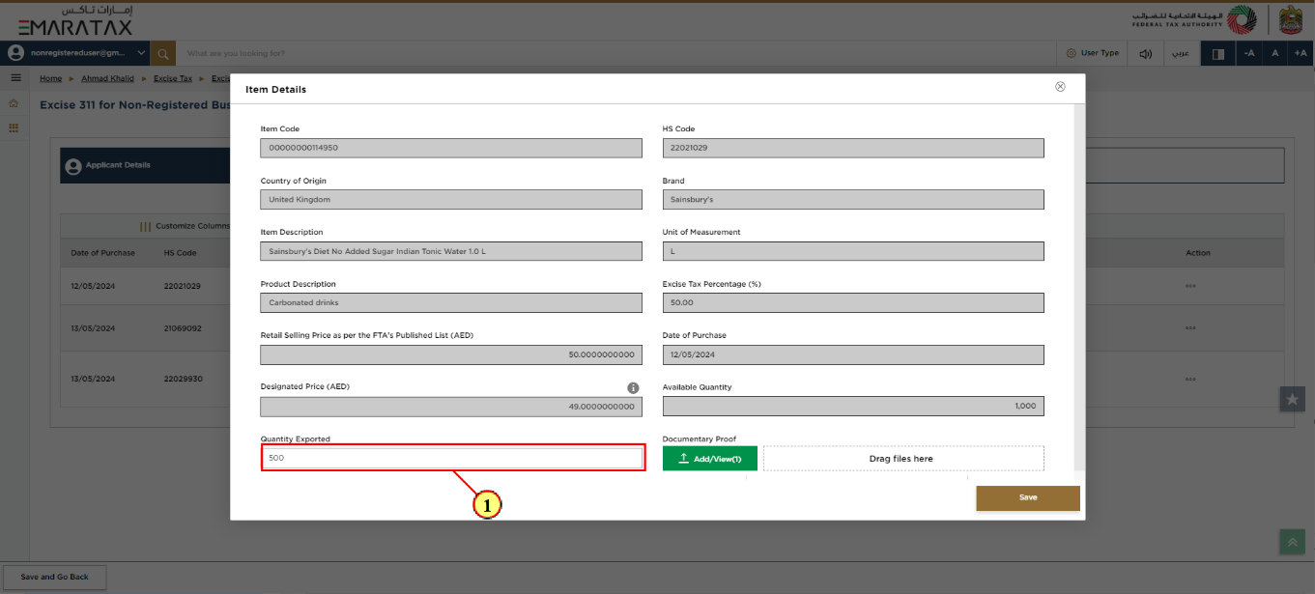

| Step | Action |
| --- | --- |
| (1) | Enter the quantity of the excise goods that were exported. |

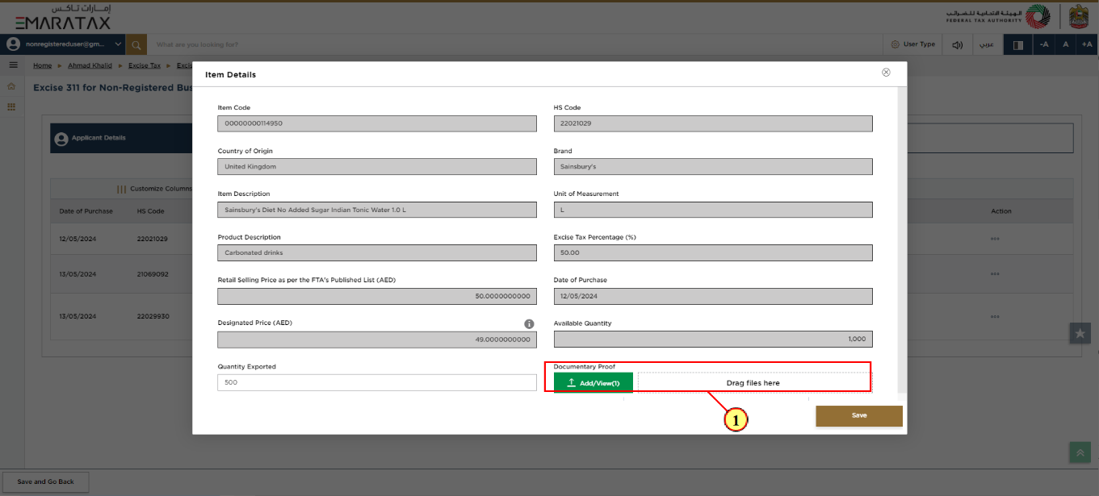

| Step | Action |
| --- | --- |
| (1) | Click on 'Add' button or drag & drop your files to upload supporting documents. On successful upload of document, the 'Add' button will be highlighted in green |

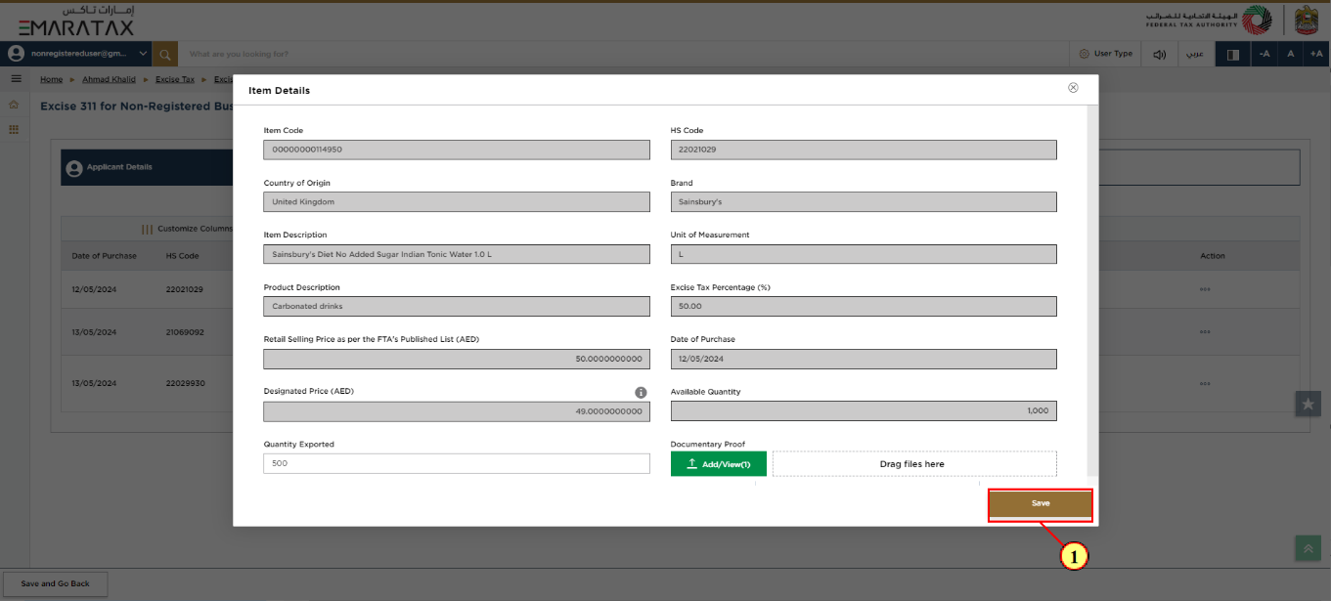

| Step | Action |
| --- | --- |
| (1) | Click on 'Save' |

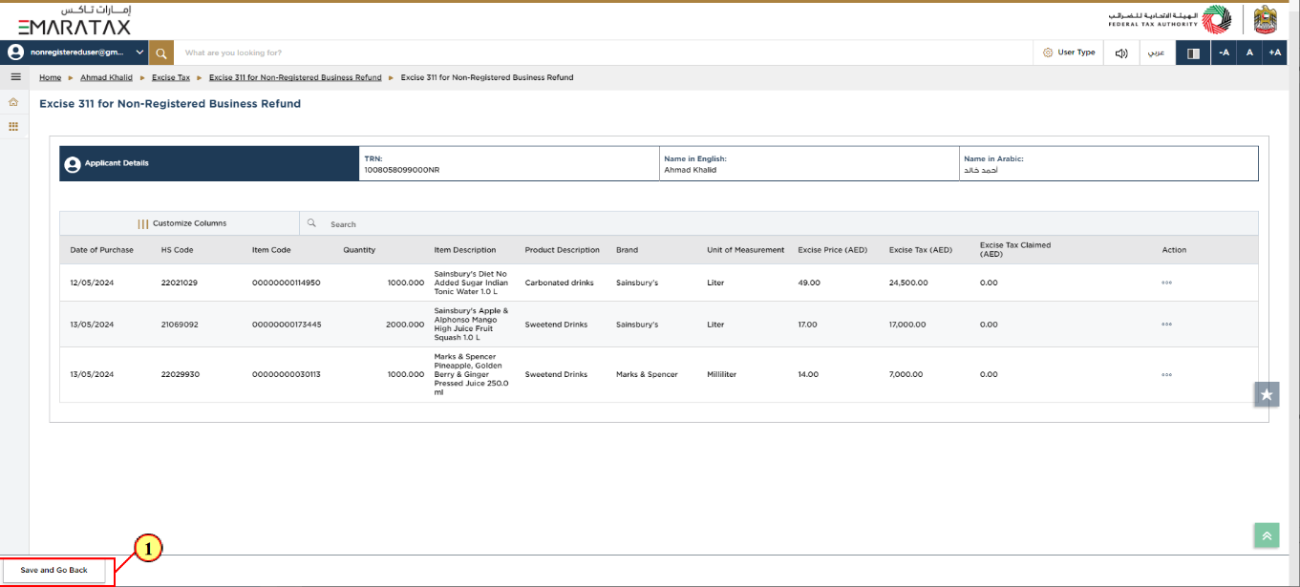

| Step | Action |
| --- | --- |
| (1) | Click Save and Back to save the progress of the form and return to the previous section |



| Information | This is the total refund amount requested by you |
| --- | --- |

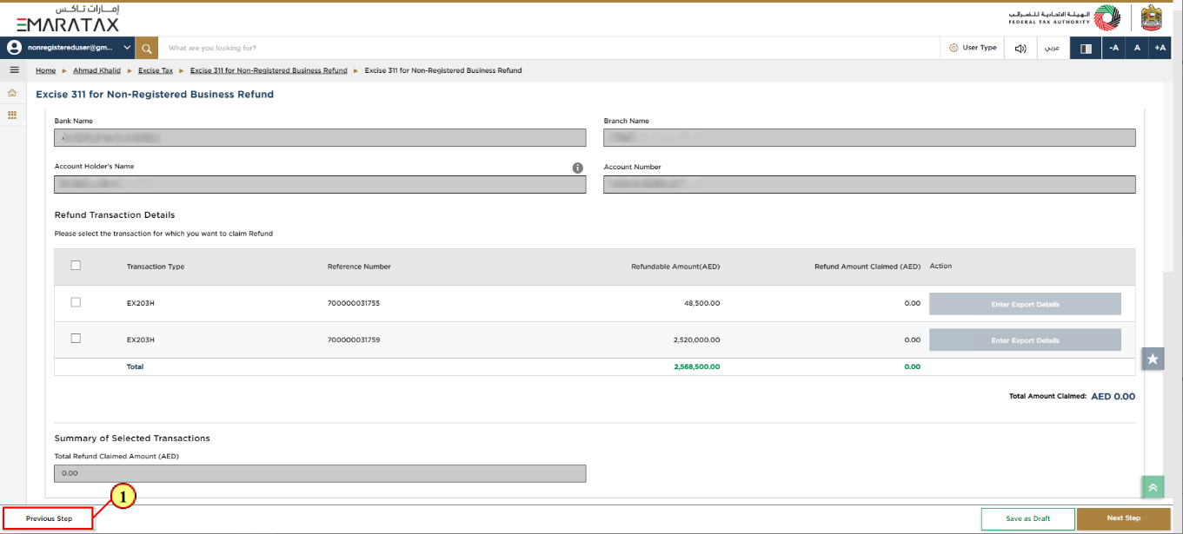

| Step | Action |
| --- | --- |
| (1) | Click on 'Previous Step' to go back to the previous section. |

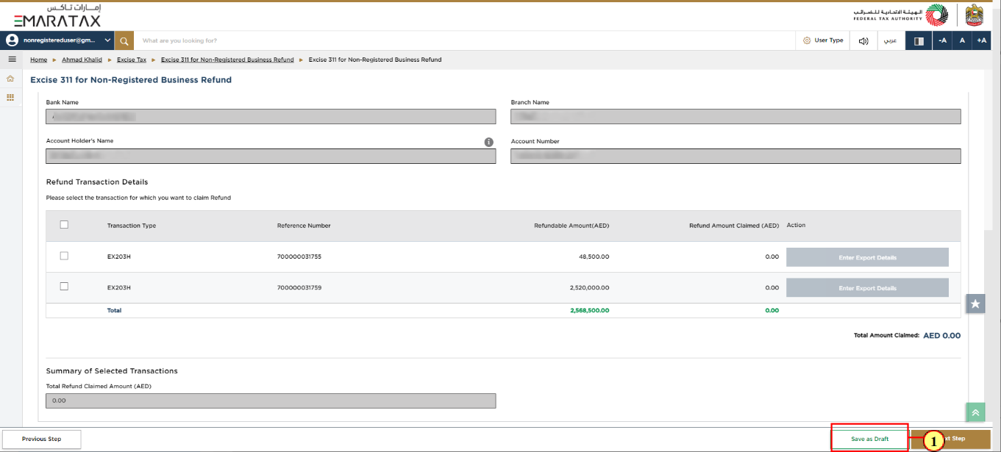

| Step | Action |
| --- | --- |
| (1) | Click on 'Save as draft' to save the refund request as a draft |

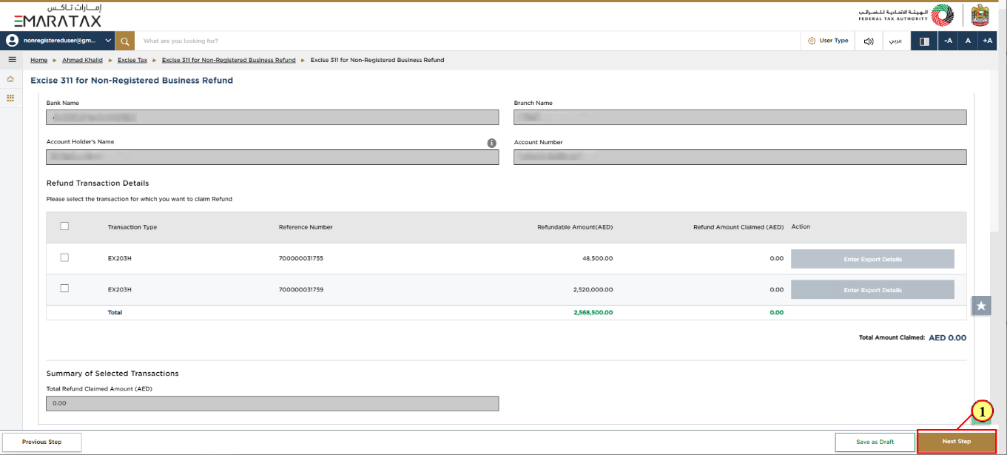

| Step | Action |
| --- | --- |
| (1) | Click on 'Next Step' to proceed to the next section |

Review and Declaration

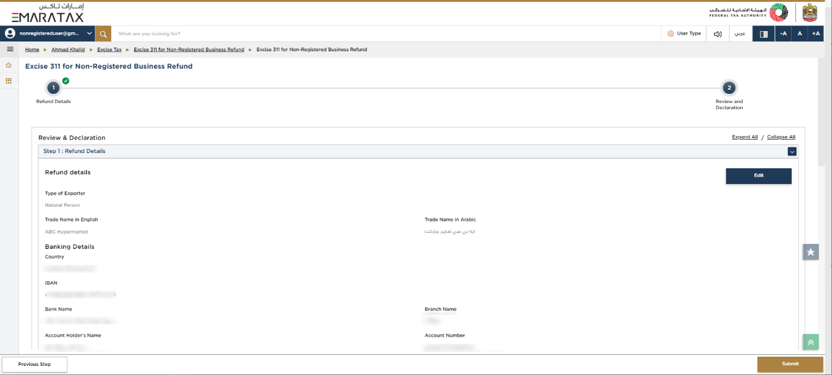

| Information | This section displays your completed declaration and allows you to review it prior to submission. |
| --- | --- |

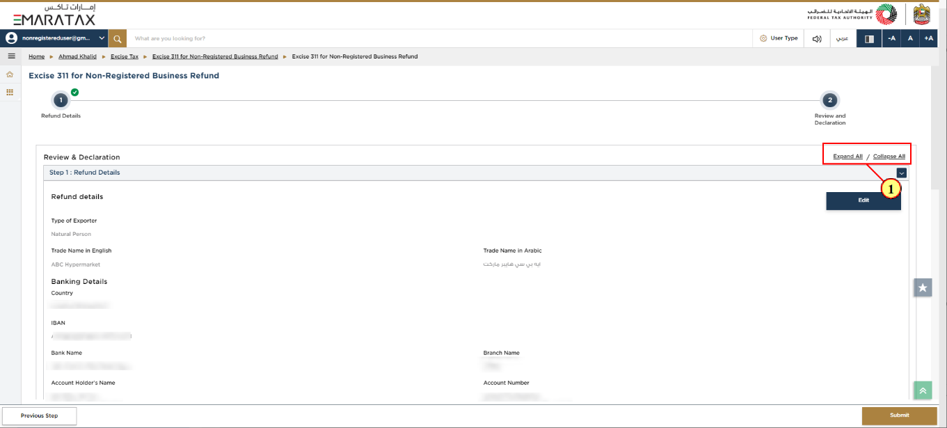

| Step | Action |
| --- | --- |
| (1) | Click here to expand/collapse all steps at once. |

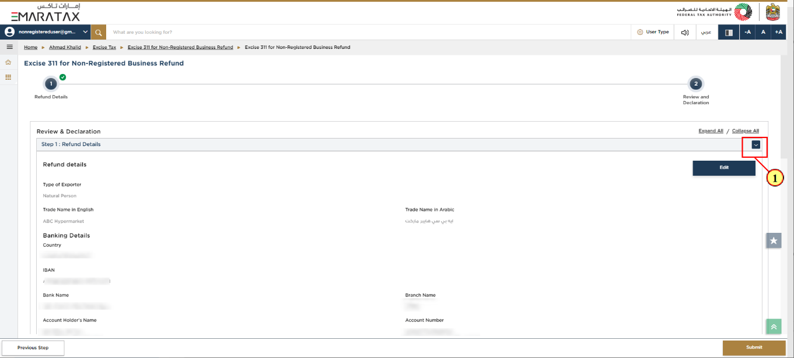

| Step | Action |
| --- | --- |
| (1) | Click on the drop-down arrow to review the details in this step. |

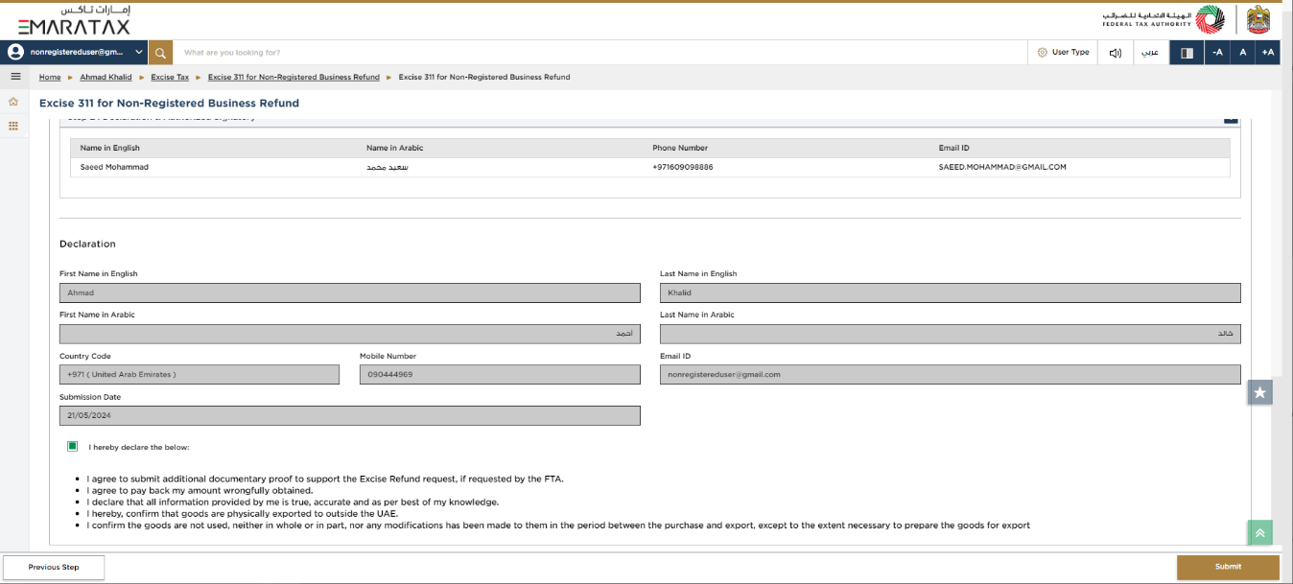

| Information | The Authorized Signatory details are taken from the Business details of the Non-Registered Businesses currently held by the FTA. |
| --- | --- |



| Information | The Declaration details are taken from the Business details of the Non-Registered Businesses currently held by the FTA. |
| --- | --- |

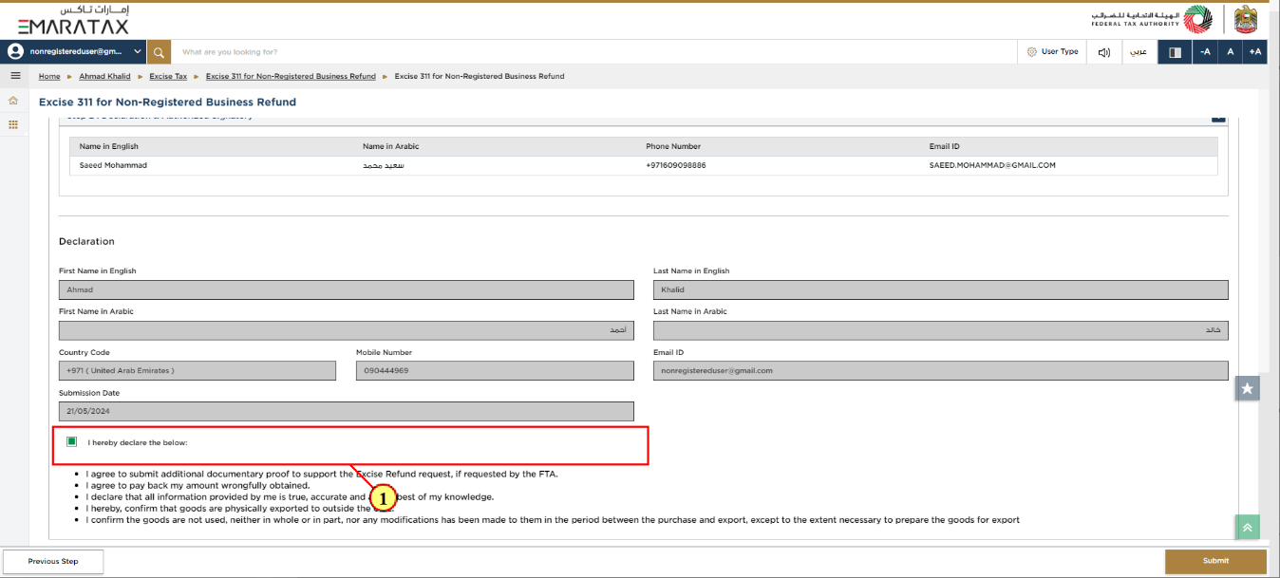

| Step | Action |
| --- | --- |
| (1) | Mark the checkbox to confirm that information provided is true, accurate and complete on this declaration screen. |

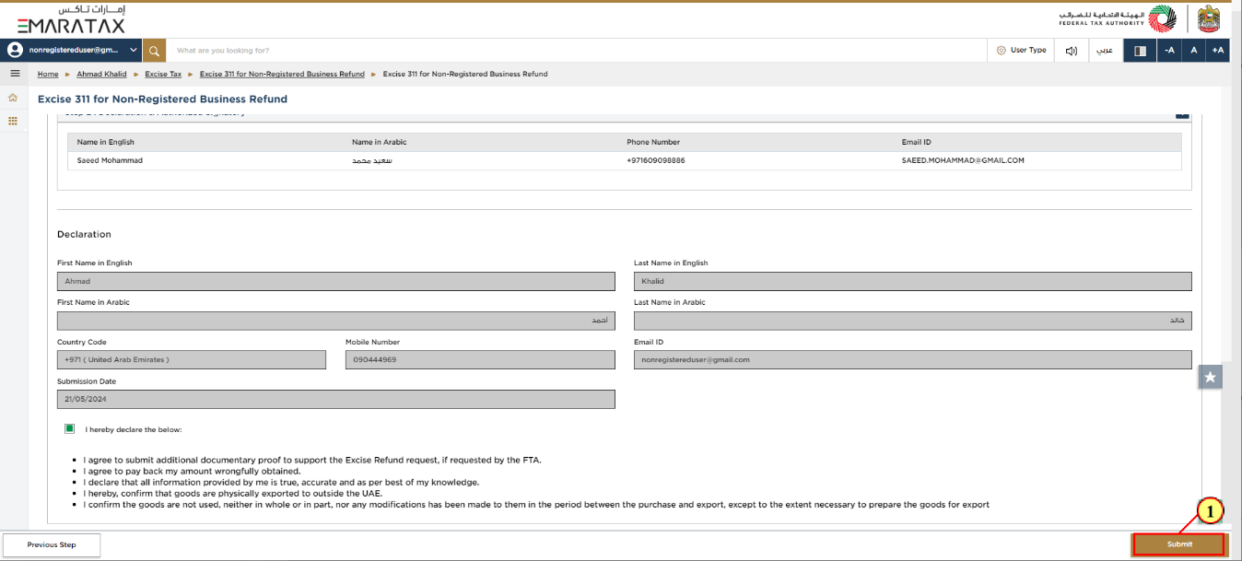

| Step | Action |
| --- | --- |
| (1) | Click on 'Submit' to submit the declaration. |

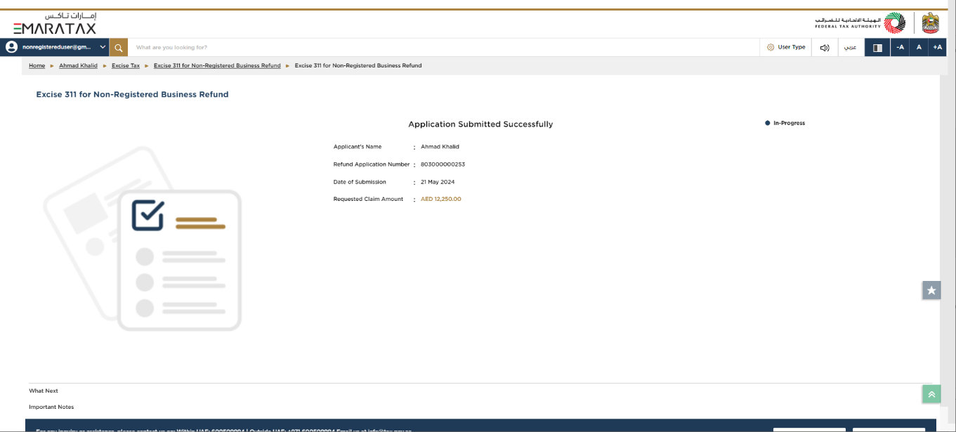

| Information | You have successfully submitted the refund request.  Make a note of the application number for future reference. You can also access this refund request from the Excise 311 for Non-registered Buisness Refunds tile within the Excise Tax module. |
| --- | --- |

